Filed by Twilio Inc.

Pursuant to Rule 425 under the Securities Act of 1933

Commission File No.: 001-37806

Subject Company: SendGrid, Inc.

Commission File No.: 001-38275

Date: October 17, 2018

The following is a transcript of the video recording of a keynote discussion between Jeff Lawson and Sameer Dholakia that took place on October 17, 2018 regarding the strategic transaction. The video recording was made available on Twilio Inc.’s website on October 17, 2018.
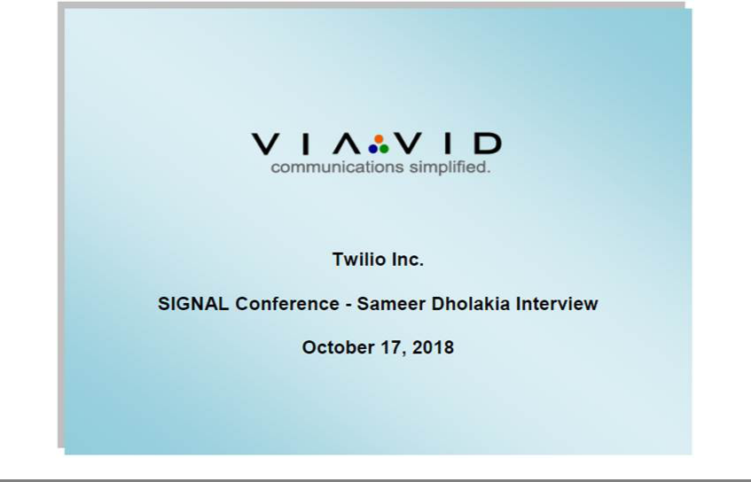

C O R P O R A T E P A R T I C I P A N T S

Jeff Lawson, Chief Executive Officer and Co-Founder, Twilio Inc.

Sameer Dholakia, Chief Executive Officer, SendGrid

P R E S E N T A T I O N

Jeff Lawson:

Sameer, welcome.

Sameer Dholakia:

Thank you. Thank you. Great to be here with SIGNAL.

Jeff Lawson:

So, first of all, tell us the story of the SendGrid journey.

Sameer Dholakia:

It’s been incredible. I think very similar to the Twilio journey, about nine years ago we started on this quest to go enable developers to embed email communications into their apps. So, you know, the simple use cases that many of the developers in the audience will recognize. When you sign up for a new service, you get a confirmation email. That email comes in your inbox, you click on it and it confirms who you are. You might hit the buy button and a receipt automatically gets triggered. If I forgot my password, I click the password button; there’s just got to be code that sits behind that to gather the right information and get it sent to you. It turned out that actually doing was more complicated than developers expected it to be.

We had three founders, developers, and they said, “This is just way too hard. You wouldn’t think that getting email sent would be that hard,” and it turns out it wasn’t the sending part; it was actually getting it delivered that was the hard part.

So, we spent the last nine years building a easy-to-adopt API for all of our developers, hopefully some in the audience here, that could just plug it in behind their applications and ensure that the emails would not just get sent but they were going to get to the inbox providers and into the main folders, not get dropped into spam. That’s what we’ve been working on.

Jeff Lawson:

I mean it’s kind of like our super network. When we go out and work with the carriers of the world, we interact, we understand how they work, we know how to reach them. We know how to deal with the whole carrier network; you have been doing the same for ISPs. You have a super network of essentially email companies, right?

ViaVid has made considerable efforts to provide an accurate transcription. There may be material errors, omissions, or inaccuracies in the reporting of the substance of the conference call. This transcript is being made available for information purposes only.

1-888-562-0262 1-604-929-1352 www.viavid.com

1

Sameer Dholakia:

Absolutely. Gmail and Yahoo! and Hotmail and the long tail of inbox providers and all the businesses out there, they have to be able to reach their users on whatever ISP they’re using.

That was really the problem that we set out to solve. Our developers said we’ve got to make it super easy to adopt, it’s got to be high-scale and it’s got to be super-reliable because as we talked about, as Christine just talked about, we’re in the business of providing trust. You guys are trusting us to make sure that those critically important communications to your users actually get there, because there is nothing more frustrating in the world than your password reset not getting there within seconds. I was just talking to Home Depot in the back who is also using SendGrid for password resets, and he said, “Yeah, that was the reason we moved over to you guys was it was taking 20 second for our customers to get their password resets from our previous solution and we had to get it over there in 1 or 2 seconds, not 20.”

That’s what we’ve been working on. We’ve been very privileged to serve now over 74,000 customers around the world, literally millions of developers have signed up on our platform, tens of thousands of startups, all the way to some of the largest businesses on the planet. You guys, we’re in your inbox every single day. If you get out of an Uber ride and that receipt shows up, that’s coming from SendGrid. If you got a recommended playlist from Spotify, that’s being delivered by SendGrid. An auction reminder from eBay, Home Depot password reset, it just goes on and on.

It’s a super scale platform because we’ve been at it a long time. We now send over a billion and a half emails every single day. That’s nearly half a trillion emails in the year. It’s a crazy high-scale system. We’re really proud of what we’ve built. We’re reaching—just to give you a sense of scale—over 3 billion unique email recipients every quarter. That’s like literally half of the world’s online population.

Jeff Lawson:

Wow. Wow. When you go talk to your customers, what are you hearing from them? Where do they want SendGrid to go next?

Sameer Dholakia:

They are very excited for us to help them solve more problems. ‘How do we get more capability so my developer doesn’t get bothered when the marketer wants to change the logo in the transactional email?’ So, we’ve added some capabilities for that in our marketing campaigns products. We are continuing to be asked time and time again, “Hey SendGrid, this is awesome. You solved this critically important channel of email. Can you help us with these other channel? You know, because our consumers all have phones in their pockets and they want push and SMS and text, “and so on and so forth. We’ve just been hearing it for so long and we would look over the fence and see, “Well, gosh. Twilio is doing such an amazing job there. How are we going to make that work?” And, here we are.

Jeff Lawson:

Right. We’ve been hearing from all of you. You want email as a part of one unified platform. SendGrid, Sameer, they’re hearing the same thing on the email side and so that’s why we think this is going to be a fabulous combination, for the kinds of things that we can build together, for all of you to build true omnichannel experiences across every part of the customer journey with email, finally, as a part of those solutions.

ViaVid has made considerable efforts to provide an accurate transcription. There may be material errors, omissions, or inaccuracies in the reporting of the substance of the conference call. This transcript is being made available for information purposes only.

1-888-562-0262 1-604-929-1352 www.viavid.com

2

As all the developers out there know, you go to hack-a-thons; what do you see? You see red track jackets and blue hoodies.

Sameer Dholakia:

That’s right.

Jeff Lawson:

Right? Now they’ll all be together.

Thank you, Sameer, for coming today.

Sameer Dholakia:

Thank you.

Jeff Lawson:

Let’s give it up for Sameer Dholakia, the CEO of SendGrid.

Sameer Dholakia:

Thank you, thank you.

Jeff Lawson:

Super warm welcome, and one reminder for anybody who’s still here during the break, at 3:45 by the SendGrid booth out in the back exhibit hall, we’re going to have cupcakes and a celebration of balloons. Come join us. We’re super fired up to bring the two best customer communications platforms in the world together, and we’re going to go help you developers go build amazing things. We can’t wait.

Sameer Dholakia:

Awesome.

Jeff Lawson:

All right. Thank you, Sameer. Let’s hear it!

ViaVid has made considerable efforts to provide an accurate transcription. There may be material errors, omissions, or inaccuracies in the reporting of the substance of the conference call. This transcript is being made available for information purposes only.

1-888-562-0262 1-604-929-1352 www.viavid.com

3

Additional Information and Where To Find It

In connection with the proposed transaction between Twilio and SendGrid, Twilio will file a Registration Statement on Form S-4 and joint proxy statement/prospectus forming a part thereof. BEFORE MAKING ANY VOTING DECISION, TWILIO’S AND SENDGRID’S RESPECTIVE INVESTORS AND STOCKHOLDERS ARE URGED TO READ THE REGISTRATION STATEMENT AND JOINT PROXY STATEMENT/PROSPECTUS (INCLUDING ANY AMENDMENTS OR SUPPLEMENTS THERETO) REGARDING THE PROPOSED TRANSACTION WHEN THEY BECOME AVAILABLE BECAUSE THEY WILL CONTAIN IMPORTANT INFORMATION. Investors and security holders will be able to obtain free copies of the Registration Statement, the joint proxy statement/prospectus (when available) and other relevant documents filed or that will be filed by Twilio or SendGrid with the SEC through the website maintained by the SEC at http://www.sec.gov. They may also be obtained for free by contacting Twilio Investor Relations by email at ir@twilio.com or by phone at 415-801-3799 or by contacting SendGrid Investor Relations by email at ir@sendgrid.com or by phone at 720-588-4496, or on Twilio’s and SendGrid’s websites at www.investors.twilio.com and www.investors.sendgrid.com, respectively.

No Offer or Solicitation

This communication does not constitute an offer to sell or the solicitation of an offer to buy any securities nor a solicitation of any vote or approval with respect to the proposed transaction or otherwise. No offering of securities shall be made except by means of a prospectus meeting the requirements of Section 10 of the U.S. Securities Act of 1933, as amended, and otherwise in accordance with applicable law.

Participants in the Solicitation

Each of Twilio and SendGrid and their respective directors and executive officers may be deemed to be participants in the solicitation of proxies from their respective shareholders in connection with the proposed transaction. Information regarding the persons who may, under the rules of the SEC, be deemed participants in the solicitation of Twilio and SendGrid shareholders in connection with the proposed transaction and a description of their direct and indirect interests, by security holdings or otherwise will be set forth in the Registration Statement and joint proxy statement/prospectus when filed with the SEC. Information regarding Twilio’s executive officers and directors is included in Twilio’s Proxy Statement for its 2018 Annual Meeting of Stockholders, filed

with the SEC on April 27, 2018 and information regarding SendGrid’s executive officers and directors is included in SendGrid’s Proxy Statement for its 2018 Annual Meeting of Stockholders, filed with the SEC on April 20, 2018.

Additional information regarding the interests of the participants in the solicitation of proxies in connection with the proposed transaction will be included in the joint proxy statement/prospectus and other relevant materials Twilio and SendGrid intend to file with the SEC.

Use of Forward-Looking Statements

This communication contains “forward-looking statements” within the meaning of federal securities laws. Forward-looking statements may contain words such as “believes”, “anticipates”, “estimates”, “expects”, “intends”, “aims”, “potential”, “will”, “would”, “could”, “considered”, “likely” and words and terms of similar substance used in connection with any discussion of future plans, actions or events identify forward-looking statements. All statements, other than historical facts, including statements regarding the expected timing of the closing of the proposed transaction and the expected benefits of the proposed transaction, are forward-looking statements. These statements are based on management’s current expectations, assumptions, estimates and beliefs. While Twilio believes these expectations, assumptions, estimates and beliefs are reasonable, such forward-looking statements are only predictions, and are subject to a number of risks and uncertainties that could cause actual results to differ materially from those described in the forward-looking statements.

The following factors, among others, could cause actual results to differ materially from those described in the forward-looking statements: (i) failure of Twilio or SendGrid to obtain stockholder approval as required for the proposed transaction; (ii) failure to obtain governmental and regulatory approvals required for the closing of the proposed transaction, or delays in governmental and regulatory approvals that may delay the transaction or result in the imposition of conditions that could reduce the anticipated benefits from the proposed transaction or cause the parties to abandon the proposed transaction; successful completion of the proposed transaction; (iii) failure to satisfy the conditions to the closing of the proposed transactions; (iv) unexpected costs, liabilities or delays in connection with or with respect to the proposed transaction; (v) the effect of the announcement of the proposed transaction on the ability of SendGrid or Twilio to retain and hire key personnel and maintain relationships with customers, suppliers and others with whom SendGrid or Twilio does business, or on SendGrid’s or Twilio’s operating results and business generally; (vi) the outcome of any legal proceeding related to the proposed transaction; (vii) the challenges and costs of integrating, restructuring and achieving anticipated synergies and benefits of the proposed transaction and the risk that the anticipated benefits of the proposed transaction may not be fully realized or take longer to realize than expected; (vii) competitive pressures in the markets in which Twilio and SendGrid operate; (viii) the occurrence of any event, change or other circumstances that could give rise to the termination of the merger agreement; and (ix) other risks to the consummation of the proposed transaction, including the risk that the proposed transaction will not be consummated within the expected time period or at all. Additional factors that may affect the future results of Twilio and SendGrid are set forth in their respective filings with the SEC, including each of Twilio’s and SendGrid’s most recently filed Annual Report on Form 10-K, subsequent Quarterly Reports on Form 10-Q, Current Reports on Form 8-K and other filings with the SEC, which are available on the SEC’s website at www.sec.gov. See in particular

Part II, Item 1A of Twilio’s Quarterly Report on Form 10-Q for the quarter ended June 30, 2018 under the heading “Risk Factors” and Part II, Item 1A of SendGrid’s Quarterly Report on Form 10-Q for the quarter ended June 30, 2018 under the heading “Risk Factors.” The risks and uncertainties described above and in Twilio’s most recent Quarterly Report on Form 10-Q and SendGrid’s most recent Quarterly Report on Form 10-Q are not exclusive and further information concerning Twilio and SendGrid and their respective businesses, including factors that potentially could materially affect their respective businesses, financial condition or operating results, may emerge from time to time. Readers are urged to consider these factors carefully in evaluating these forward-looking statements, and not to place undue reliance on any forward-looking statements. Readers should also carefully review the risk factors described in other documents that Twilio and SendGrid file from time to time with the SEC. The forward-looking statements in these materials speak only as of the date of these materials. Except as required by law, Twilio and SendGrid assume no obligation to update or revise these forward-looking statements for any reason, even if new information becomes available in the future.

4

